West Sac Community Radio
West Sacramento Neighbors Fair, Inc.

Executive Summary

Purpose of the Organization
West Sacramento Neighbors Fair, Inc. (Neighbors Fair), 501 c(3) non-profit corporation established in 2003, seeks to recognize and promote West Sacramento as a culturally diverse city with a rich heritage. Originally, the organization sponsored a free annual public, multi-cultural fair for seven years with the goal of educating local citizens about the various cultural traditions within the community, including the contributions of ethnic minorities such as the Portuguese, Latino, Russian, Sikh, Southeast Asian, Native American and African Americans.

From 2016, the new leadership of Neighbors Fair, Inc. has been committed to continuing the mission and promoting the cultural diversity and heritage of West Sacramento. The articles of incorporation, bylaws and policies of West Sacramento Neighbors Fair, Inc., all support a broader educational mission that includes operation of a non-commercial radio station and a dynamic online audio streaming channel. In 2014, the Neighbor’s Fair Board sought approval from the Federal Communications Commission for a license to operate a Low Powered FM broadcast radio station originating from West Sacramento. In March of 2015, the Neighbors Fair successfully obtained a construction permit by the FCC entitling it to proceed with the construction of radio station identified under the call letters KYWS-LP (Know Your West Sacramento).

The proposed educational programming for this license includes the following strategies to educate and inform the local community about our rich cultural, social and economic diversity by various means:
- Report local West Sacramento and Yolo County news and events, including broadcasting live events
- Broadcast local achievements and perspectives in public affairs , the arts, science and the environment
- Encourage and cultivate multicultural radio programming, with subject matter and hosts from West Sacramento’s various ethnic populations such as Portuguese, Latino, Russian, Sikh, Southeast Asian, Native American and African American.
- Train community members in the production of non-commercial radio programming
- Partner with West Sacramento educational institutions and non-profits to provide an avenue for information exchange, community dialogue and career development. For example, students will be able to learn to produce local music, informational programming and public service announcements and to broadcast live accounts of scholastic sports events, such as high school football games.
- Promote the dissemination of information for health and public safety. For example: in the event of a flood or other disaster, KYWS radio will collaborate with the City of West Sacramento and public safety personnel to augment information provided to West Sacramento residents. In addition, KYWS will provide resources to support the AARP Age- Friendly Community initiative. The station will also have the technical ability to communicate remotely with City “reader boards” which provide visual information messages at key traffic areas around West Sacramento.
- Offer a diverse musical program to expose listeners to local and culturally diverse music forms.

All these programs will educate and enrich the local community.

Our path forward
West Sacramento Neighbors Fair has developed and adopted a strategic plan that is dynamic in nature and can be used as a guide for the development and planning processes of its future. The main goals and objectives for the organization are delineated herein and include the following broad goals and correlated key action steps:
Board, Volunteer, Community Development
Strengthen the effectiveness of the Board of Directors through more training and by attracting key community members to serve on the board.
Provide paths of opportunity that improve professionalism through training, policy development, and personal accountability.
Increase and broaden the volunteer base of support to Neighbors Fair by the board and staff by providing positive opportunities for enhancement of meaningful volunteer experiences within the organization.
Participate through the board and volunteers in regional efforts that forward Neighbors Fair’s mission.
Programming Creation and Improvements
The heart of Neighbors Fair has been that of community activities. It will now add to that focus broadcast programming, which will become the face Neighbors Fair presents to a listening public. Procedures and protocols will be developed and implemented that facilitate a rewarding experience for volunteer based content development that speaks to the richly diverse communities served by the broadcast airwaves and online presence.
Marketing and Community Outreach
Develop community relationships that will reflect the diversity of West Sacramento, East Yolo and the Sacramento metro areas and to reach potential listeners in all age, racial, social, and economic groups.
Create a more relevant presence for Neighbors Fair in the local media market. Develop new branding to promote the services and resources of the Neighbors Fair community.
Media Center
Improve and enhance the online presence of Neighbors Fair programming with appropriate applications for modern media tools.
Create a Neighbors Fair media center that improves programming through more training, improved policies, and increased personal accountability for follow-through.
Financial Sustainability
Increase community support through training, education, and outreach.
Develop policies that will create a sustainable membership of approximately 3,000.
Implement fund raising strategies that will address the demographics of the membership and seek additional grant resources.
Implement a consistent grant writing effort to increase revenue for training, outreach, education, and support to the diverse communities of the market area.

Our Startup Finances

Rent and Utilities
We are currently in discussions to rent administrative and startup studio space that will include utilities and internet connectivity. We are also looking into using an IP type phone service such as Vonage as our provider.

Volunteer Power
As is true for many new stations we are planning to use volunteers exclusively during our first year of operation. However, there are tasks that may require paid services and they would include volunteer coordination and training, accounting, fundraising, and general record keeping. Funding of these positions would be driven by the development and successful execution of Underwriting and Sponsorship's campaign.

Underwriting and Sponsorship’s

As a community focused, noncommercial, educational radio station, some of the ways KYWS-LP funds its programming and general operations is through underwriting and sponsorship support from local businesses, foundations and corporations. Guidelines have been designed that will preserve the noncommercial nature of KYWS-LP that are consistent with our programming values, as well as with FCC requirements. Your support represents a partnership between your organization and KYWS-LP, and demonstrates your commitment to the community.

Content Licensing

We are basing our programming on locally generated community content. However, if we play any content on the air that is licensed, we understand we are required to pay licensing fees. Licensing fees are paid to Performance Rights Organizations (PROs) that in turn pass on money to artists and composers.

Startup Equipment Costs
Low Power FM Transmission System
Qty | Unit | Description | Price | Options
1 |  | 600w BW BROADCAST TX600-V2 FM Broadcast BW-TX600-V | 4,285
1 |  | Toroid Kit – NAU-VS-TOROID | 50
1 | lot | Transmitting antenna Broadband Circular Polar - NICBKG77 | 610
500 | ft | 1/2” Foam Heliax cms-ldf4-50a w(cms-241088-1,cms-241088-1 & frvsm4534 ) | 750
1 |  | Digital Alert Systems DASDECII-LC | 1,950
1 |  | 3PH/1PH 200v-415v nvlt ac Line Protector – NAU-SURGE-3PH/1PH | 750
1 | lot | Miscellaneous wire, ground strap, & installation materials | 500
1 | lot | Labor for installation of transmission system | 2,500
 |  | Estimated Costs | 11,395
 |  | Estimated Costs with options
 |  | Total Funds Raised ( Donations and Matching 2017-2018) | 15,000
Startup Equipment Costs (cont)

Low Power FM On-Air Control Room (Media Center, optional)
Qty | Unit | Description | Price
1 |  | Audio console w/monitor amplifier | donated
2 | lot | Computer system w/sound card @ $375 | 750
2 |  | Microphones w/booms and adapter @ $60 | 120
2 |  | Broadcast quality CD players @ $75 | 150
2 |  | Audio2000'S AMX7303 Professional Four-Channel Audio Mixer with USB and DSP Processor @ $60 | 120
2 |  | Behringer U-Control UCA202 Ultra-Low Latency 2 In/2 Out USB Audio Interface with Digital Output | 60
1 |  | Barix 100 xstreamer (optional: PC ) | 195
1 | lot | Miscellaneous wire,ground straps & installation materials | 250
 |  | Estimated Costs | 1,645

Operations Budget (proposed) – 2nd Year
Revenue
Underwriting |  | 5,000
General donations |  | 3,000
Benefit events |  | 2,500
T-Shirt, media sales |  | 1,000
Grants |  | 1,500
In-kind donations (studio space) |  | 2,400
Total Revenue |  | 15,900
Total Funds Raised 2019 |  | 1,275
Expenses
Rent | 1,200
Electricity | 0
Phone | 300
Garbage & sanitation services | 0
ASCAP,BMI,SESAC (music licensing) | 425
SoundsExchange (music licensing) | 250
Pacifica (membership dues) | 225
Office Supplies | 550
Printing | 450
Insurance | 1200
T-Shirt printing | 200
Postage | 50
Equipment | 1200
Total Expense | 6,050

KYWS-LP Broadcast Reach (Market Area by 60 dBu) Population 105,318 2010 census

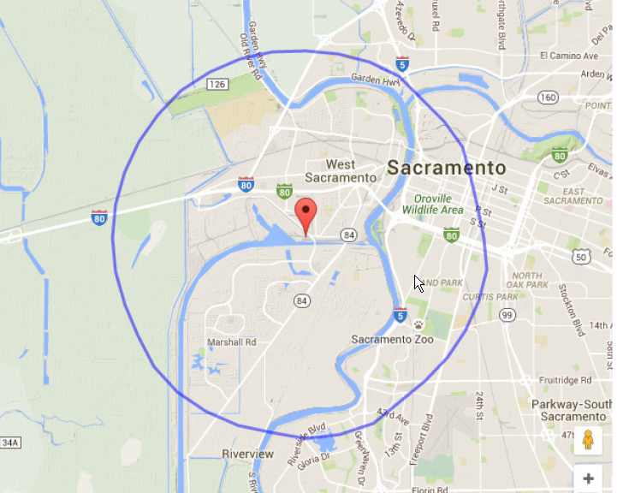

Antenna / Transmitter Building Port of West Sacramento

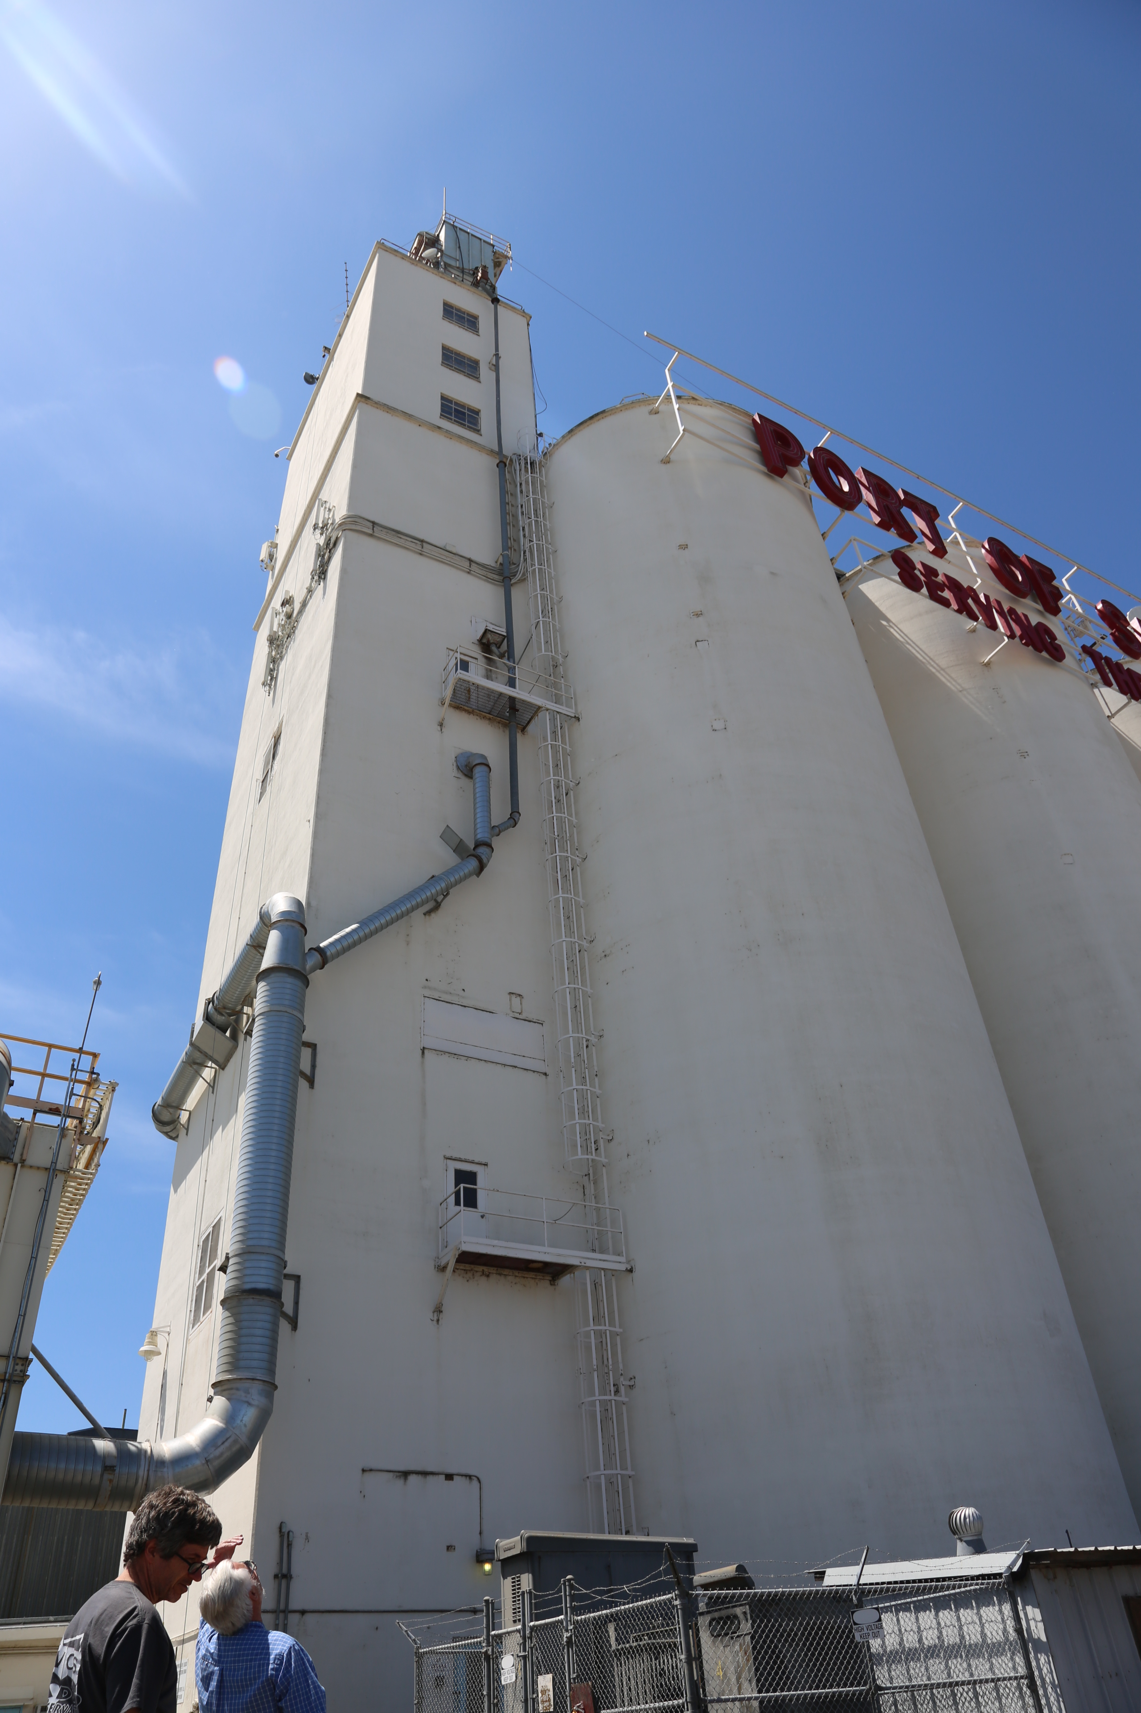

Our Antenna – Sideways T
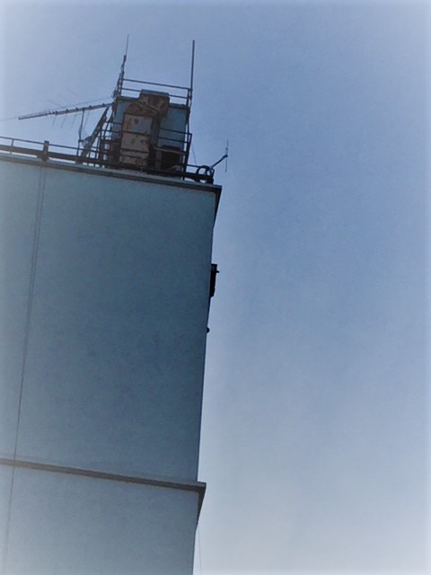

Our Transmitter House

